Harsha Vardhan
2400040454..
EXPERIMENT No: 7

Create VR 3D Environment by using Co-spaces

Aim:

Sure! Here's the aim in simple words:
The goal is to create a 3D VR environment using CoSpaces where people can explore and interact with different objects and elements. This could be for fun, education, or other purposes. You'll design a virtual world with objects, animations, and interactivity, and allow users to experience it in VR.

Software Requirements:
Here are the basic requirements:
- CoSpaces Account (free or paid)
- Web Browser (Google Chrome, Mozilla Firefox, or Microsoft Edge)
- VR Headset (optional for VR viewing, e.g., Oculus Quest, HTC Vive, Google Cardboard)
- CoSpaces Edu App (for mobile VR experience, optional)

Pre-lab Session:
- Sketch the environment you need to create.

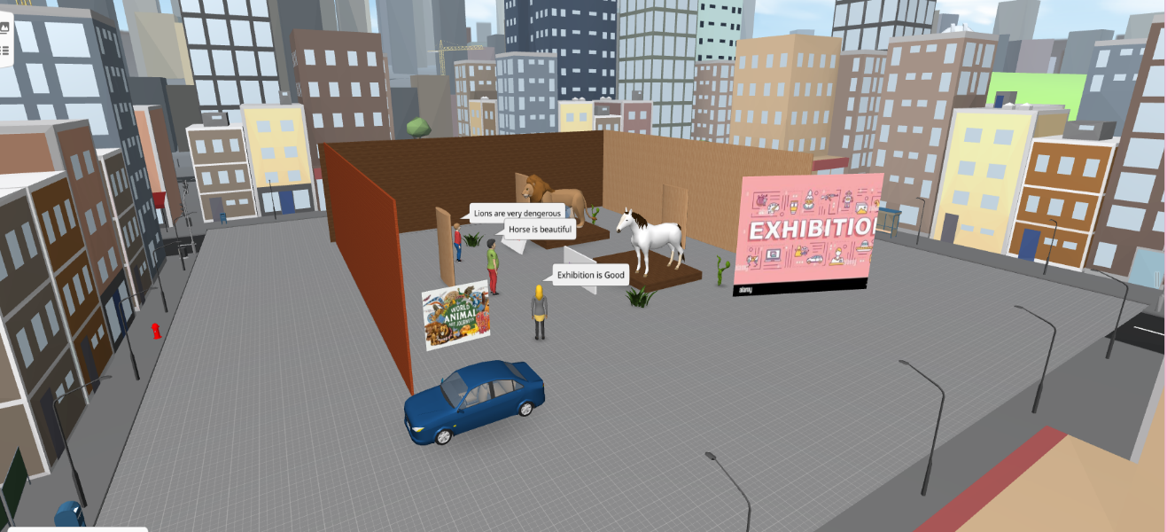

- Enlist the components required and create login credentials in Cospace online platform.

Here are the components required:
- Computer or Mobile Device
- Internet Connection
- CoSpaces Account (Email or Google account)

Procedure:

Here’s an expanded step-by-step procedure to create login credentials on CoSpaces:
- Go to CoSpaces Website: Open your web browser and visit https://cospaces.io.
- Click on "Sign Up": On the homepage, find and click the "Sign Up" button in the top right corner.
- Choose Signup Method:
  - You can sign up using Google or Email. Choose your preferred method.
- Sign Up with Google (Optional):
  - If you select Google, simply log in with your Google account credentials.
- Sign Up with Email:
  - If you select Email, fill in your name, email address, and create a password.
  - Make sure the email you enter is valid.
- Agree to Terms: Read and agree to CoSpaces’ terms and conditions (if prompted).
- Verify Your Email:
  - CoSpaces will send a verification email to the address you provided. Open your email inbox and click on the verification link to confirm your account.
- Log In:
  - Once your email is verified, go back to CoSpaces and click "Log In".
  - Enter your email address and password, or use your Google account if you signed up that way.
- Start Creating: After logging in, you’ll be directed to your dashboard where you can start creating your VR 3D environment!
That’s it! You're all set to begin exploring and creating in CoSpaces.

Results (All screen shots need to paste here):

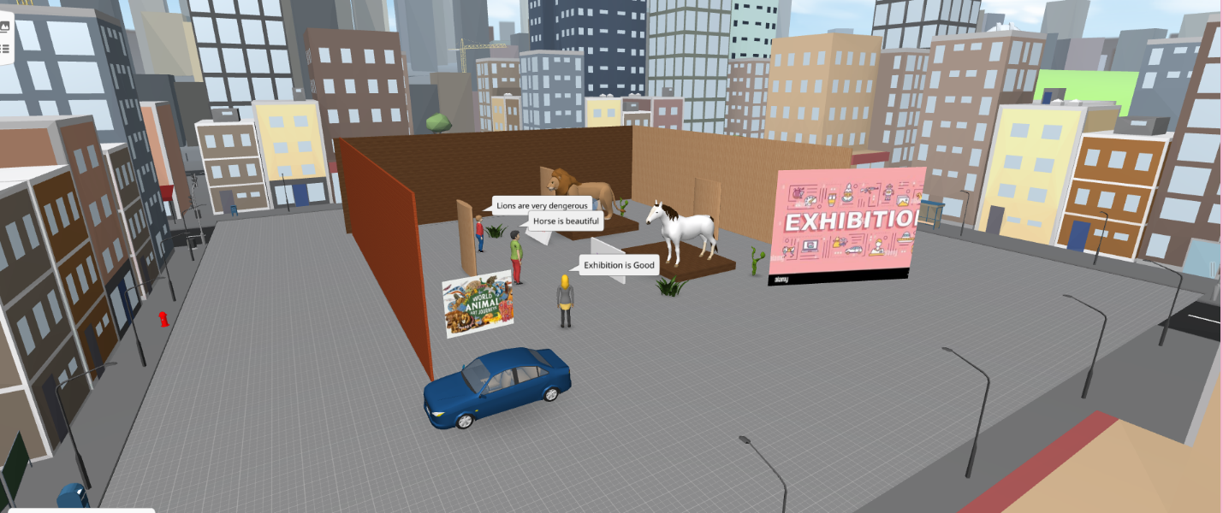

POST-LAB

1.What is virtual reality?

Virtual Reality (VR) is a technology that creates an immersive, computer-generated environment that you can interact with using a headset.

2.Write the procedure to create a virtual scene in Cospace?

To create a virtual scene in CoSpaces, log in, start a new project, add and arrange 3D objects, set a background, add interactivity and animations, then save and share your scene.

3.How to give motion to any object/ item?

To give motion to an object in CoSpaces, select the object, go to the "Animate" panel, choose the motion type, set the parameters, and add a trigger if needed.

LAB REPORT RUBRIC

LAB REPORT ITEMS | Points | Points  Received
VIVA | 5
EXPERIMENT REPORT  (All steps clearly stated) | 15
OBSERVATIONS AND DATA | 15
TOTAL | 20

